ДА ЛИ ЋЕ ДИГИТАЛНИ СИСТЕМ ЗА УПРАВЉАЊЕ ГАЗДИНСТВИМА ПОКРЕНУТИ СЛЕДЕЋУ РЕВОЛУЦИЈУ У ПОЉОПРИВРЕДИ СРБИЈЕ?

WILL DIGITAL FARM MANAGEMENT SYSTEM TRIGGER THE NEXT REVOLUTION IN SERBIAN AGRICULTURE?
OСКАР МАРКО, САЊА БРДАР, ПРЕДРАГ ЛУГОЊА, ГОРАН КИТИЋ, МАРКО ПАНИЋ, ДАМИР КРКЉЕШ, ВЛАДИМИР ЦРНОЈЕВИЋ

Abstract

Human population is growing rapidly and so is its demand for food. Digital technologies possess huge potential for revolutionising agriculture, as sensors, drones and satellites have already proven to be effective in crop monitoring and optimisation of agricultural activities such as irrigation, pest management and fertiliser application. However, the uptake of new technologies has not met the expectations. For this reason, a platform for digital agriculture of Serbia was designed, called AgroSense that so far gathered more than 20,000 users, whose total area equals one quarter of all Serbian farmland.

Keywords: AgTech, IoT, farm management information system, AI, agriculture

Апстракт

Светска популација убрзано расте, а са њом и потреба за храном. Дигиталне технологије поседују велики потенцијал да унесу револуцију у пољопривреду, како су се сензори, дронови и сателити већ показали као ефективни у мониторингу усева и оптимизацији пољопривредних активности попут наводњавања, регулисања биљних болести и примене ђубрива. Ипак, прихватање нових технологија не иде одговарајућим темпом. Из овог разлога је развијена платформа за дигиталну пољопривреду Србије, по имену АгроСенс, која је до сада окупила 20.000 корисника чија укупна површина је једнака четвртини обрадиве површине земље.

Кључне речи: АгТех, интернет ствари, информациони системи за управљање газдинствима, вештачка интелигенција, пољопривреда

1. Introduction

One of the areas that are going through the most dramatic change in the break of the Fourth Industrial Revolution is agriculture. Today, more than ever, manufacturers are under huge pressure to increase yields, reduce costs and grow quality products. This is not an easy task and requires dedication, hard work and investments, and the only way to succeed is to make the decisions exceptionally efficient and timely. In the era of satellites, powerful computers and the internet, we finally have the opportunity to make decisions based on facts, and the key to success lies in data.
Moisture sensors, weather stations, yield monitors, drones and soil sampling probes have become a common sight on our fields, and they all are nothing more than different platforms for obtaining the data. Using them, we are getting information about the soil type, terrain elevation, crop growth and yields, and counting in the specifics of a particular field, we are optimising the choice of varieties and hybrids, planting date, amount and type of fertiliser, as well as the right moment for irrigation. In this way, we are providing all the necessary conditions for good plant growth and preventing excessive use of agrochemicals.
There are different architectures of agricultural IoT systems, but what they have in common are the following layers [1]:
- Perception layer. This layer encompasses different sensing devices. They include soil moisture sensors, weather stations, imaging devices and other devices for data acquisition.
- Network layer. Communications between the devices and the cloud are realised through this layer. Low Power Wide Area Networks (LPWAN) such as NB-IoT and Lora are the most widely used, but there are applications which rely on ZigBee or Wi-Fi, as well.
- Application layer. This layer deals with data storage and manipulation. Based on the acquired data actions are taken, either by expert decisions or using machine learning and artificial intelligence.
Different architectures with these layers have been designed and applied in various use-cases. SWAMP, a Brazilian water management system relies on soil moisture sensors and drones for data acquisition [2]. Information from sensors is transferred through LoRa network to the cloud and ultimately serves as the input for decision-support systems (DSS). Such systems are especially important for growing high-value crops, such as grapes. In a study presented in [3], sensors are gathering air temperature, humidity, leaf wetness and soil moisture and their readings are used for optimising the irrigation in vineyards. Another interesting application of IoT in agriculture is crop disease monitoring. A system proposed in [4] uses weather measurements along with cameras and pH measurements to assess the risk of disease occurrence. Due to its real-time operation and SMS notification service it has the potential to make decision-making timely and accurate. Other examples of IoT applications in agriculture include animal activity monitoring [5], optimisation of aquacultural production [6] and food storage and transport monitoring [7].
Although there have been successful solutions applied in agriculture, IoT is still not used as widely as it could be. Agriculture in general has the lowest uptake of new technologies [8]. There are multiple reasons for this, which fall into two groups: sectorial and technological limitations. Sectorial limitations include problems such as the heterogeneity of use-cases, farmer profiles and farm sizes, applicability of business models and data ownership, while technical limitations are concerned with the lack of interoperability of solutions, problems with connectivity and privacy.
In Serbia, one of the main problems was that data from various sources has been hardly available to the farmers. They were located in different places, in different formats, and some were not even available in the digital format. The AgroSense platform is an attempt to tackle this problem and bring new technologies such as IoT and remote sensing closer to farmers. The platform for digital agriculture of Serbia gives farmers the opportunity to run their farms digitally, professionally and efficiently, completely free of charge.
AgroSense has been developed to ensure that the farmers have a quick and easy access to data, but also to let the community benefit from BioSense’s top-class research in the domain of applied artificial intelligence, satellite image processing and the development of sensor networks. Since the platform launch in October 2017, we have gained more than 11,000 satisfied users, which confirms that Serbian farmers have recognised the importance of digital transformation in their area. The platform consists of a number of modules and their number is increasing constantly from one month to the other, to answer to the requirements in the production.

2. Using the Service

Everyone interested in AgroSense can register at www.agrosense.rs completely free of charge, for what you they only need to have an email address. The first step after the registration is defining the production parcel (Figure 1). This can be done through the cadastre, if the user possesses the data about the municipality and the cadastral ID. The user can also select more than one parcel, if the crop production spans over a few of them. On the other hand, it often happens that multiple crops are produced on one cadastral parcel, which is why there is a possibility for the user to draw the boundaries of the production parcel using the map and a simple drawing tool. The user can have an unlimited number of production parcels on its profile and immediately after creating the parcel in the system, the whole range of modules becomes available. These modules are described in detail in the following chapters.

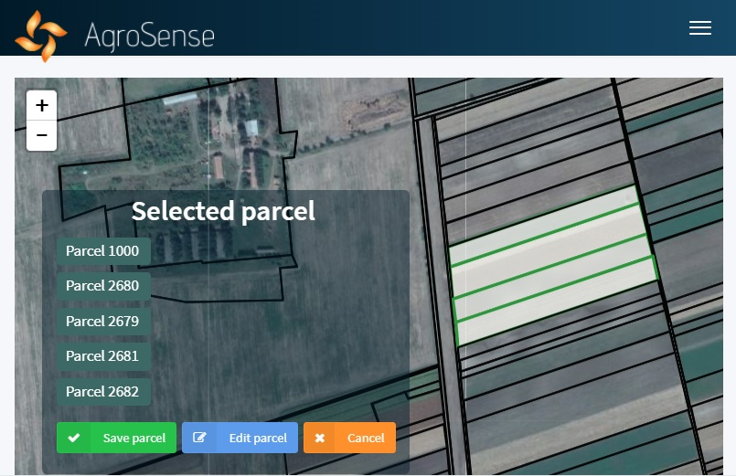
Figure 1. Users can select their fields from the cadastre or draw them if the cadastral parcels do not match the production parcels

3. Weather

Scientific results are telling us that the weather is responsible for 70 % of the variability in yield. Due to the climate change, extreme weather events such as droughts and floods have become very frequent and have a distinctively local character. Serbian Hydro-Meteorological Agency’s network covers around 30 geographic locations, but this number is far from sufficient. It often happens that weather events occur between two weather stations and remain unregistered, which is a serious problem for farmers, who make decisions based on meteorological data. For this reason, BioSense has started deploying a staggering number of 500 weather stations throughout the Republic of Serbia. These stations may have somewhat lower accuracy than the ones used by the official meteorological agencies but they allow for measuring meteorological parameters on a high spatial resolution, which is usually a lot more important. A LoRa [9] network system has been installed across the territory of Serbia for wireless integration of weather stations. Just as the mobile network is optimised for sending large files, such as high-quality images and videos, LoRa is optimised for sending small batches of data, like sensory readings, over vast distances with small energy consumption. In this way, a battery can last throughout the whole growing season and data logging is possible from fields up to 30 km away from the base station. AgroSense’s module shown in Figure 2 displays real-time weather data from the chosen weather stations.

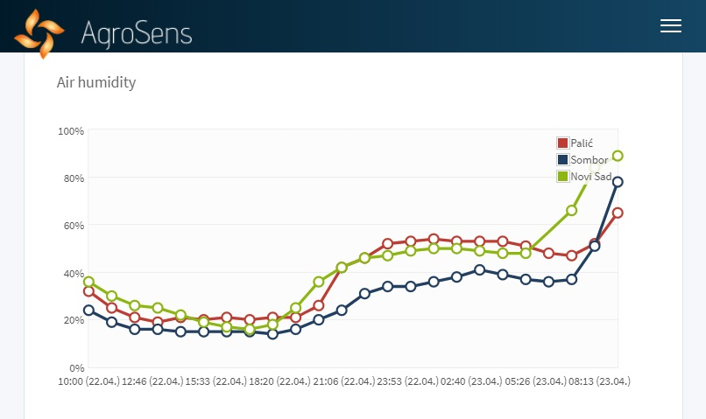
Figure 2. Users can choose up to three weather stations closest to their field, from which they are getting real-time data over LoRa network
Besides the module for real-time monitoring of meteorological parameters, there is a module for the weather forecast as well. Researchers at BioSense Institute have a long history of using the forecast issued by the Norwegian Meteorological Institute [10], as it is in our experience among the most accurate ones. What is more, the forecast is given at a resolution of 2 km, which allows the user to have an accurate forecast for the location of its field. Soil temperature is a decisive parameter for sowing, rain forecast determines the optimal moment for the application of fertilisers and pesticides and solar radiation and air temperature are influencing the plant development and thus the harvesting date. Based on the local forecast and local readings from weather stations, farmers can have a precise insight into the state of the field through AgroSense and they can make optimal decisions in their production.

4. Satellites

Besides Canada, Serbia is the only country outside the EU that has wideband access to imagery from Sentinel satellites of the European Space Agency, and AgroSense is fully utilising this opportunity. Sentinel satellites are taking footage of crops every 5 days at a resolution of 10 m and allow the user to monitor its fields from a completely new perspective. Just as the human eye recognises 3 components of light (red, green and blue), Sentinels recognise 13 spectral components. This means that they see what we do not see and sometimes it is the infrared and thermal bands that are telling the most about the “health status” of the plants. Using 13 spectral channels, we are calculating vegetation indices that are telling us about the growth of crops, drought intensity, dispersion of plant diseases and the plants’ needs for irrigation and fertilisation. In this way, farmers can see which parts of the field are growing better and which are growing worse, and they can distribute the fertiliser according to the actual needs of crops in different parts of the field (Figure 3).

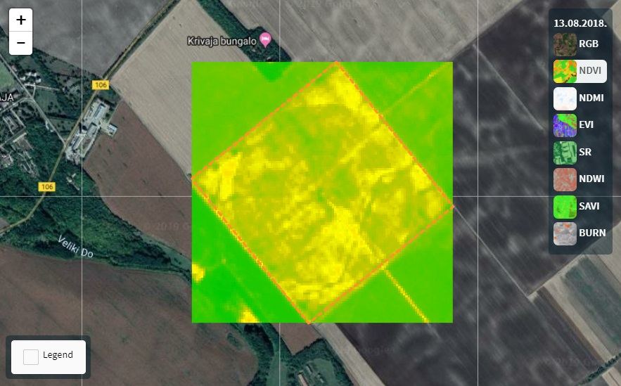
Figure 3. Images from European Space Agency’s satellites are coming every 5 days and various vegetation indices are displayed

5. Parameter Maps

Besides satellites that are covered by a separate module, there are many other sources of data about the parcel, such as yield, elevation and soil electrical conductivity maps and drone footage. These maps are additional layers of information that can be extremely important in planning and monitoring the growth of crops. There is a possibility to import these maps into AgroSense and compare them with one another. The image in Figure 4 is an example of how the soil electrical conductivity maps are uploaded to the system and shown to farmers in a user-friendly way. On the other hand, drones are allowing us to observe crops on a resolution of just a couple of centimetres and spot the finest changes in crop growth. Additional parameter maps are giving us a new insight into agricultural production, and AgroSense is giving us an opportunity to show them to the farmers and analyse adequately.

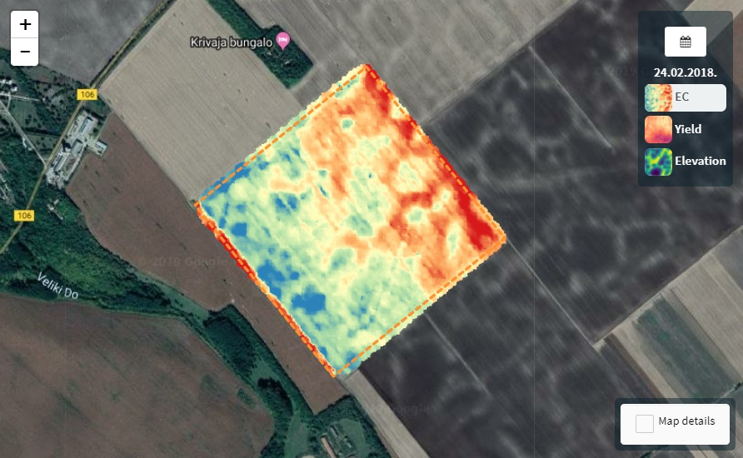
Figure 4. Parameter maps such as soil electrical conductivity, yield and elevation are shown as additional layers of information about crops

6. Sensors

In the two previous sections we mentioned satellites, drones and other technology that allows us to cover vast areas with coarse measurements. Sometimes, however, it is important to have precise local information and that is where IoT comes into play. Just as weather stations, sensors for soil moisture, water level, leaf wetness or silo monitoring can be integrated into the AgroSense platform, for real-time monitoring of the parameters (Figure 5).

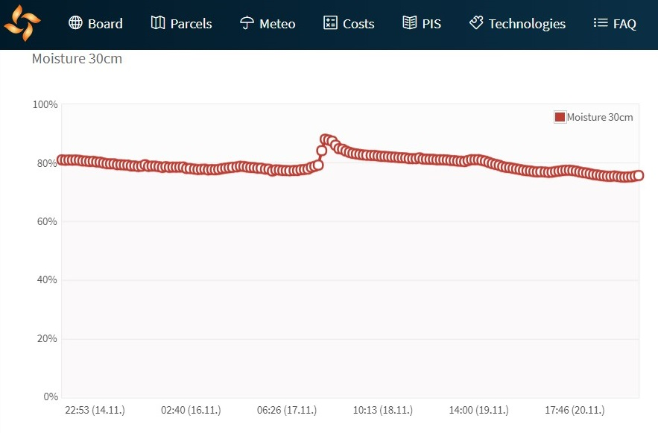
Figure 5. Various sensors such as soil moisture sensors can be connected to the system using LoRa network and their readings can be displayed in real-time

A practical example of their use in agriculture is smart irrigation. Last year, BioSense has installed soil moisture sensors, along with a weather station, at a test field located on the Pannonian Plain, near Novi Sad, Serbia. Management zones that have homogeneous soil properties were delineated using the data from the electromagnetic soil probe Geonics EM-38. Sensors were placed in the centre of each zone, and their readings were taken as representative of the whole zone they were installed in. The weather station measured the amount of precipitation at the field, so that a precise machine learning model could find a relationship between a) the amount of rainfall and soil moisture and b) the duration of irrigation and soil moisture. The first model predicted the soil moisture level based on the weather forecast, while the domain knowledge helped us define the critical moisture levels in different growth stages of maize. In this way we could predict the exact moment when the plants should be irrigated, while the second model gave us the precise duration for which the farmer should turn on the irrigation system on (Figure 6). This system lowered the consumption of water and diesel pumps needed for running the irrigation system by more than 40 % and secured that the yield would not be affected by the water stress [11].

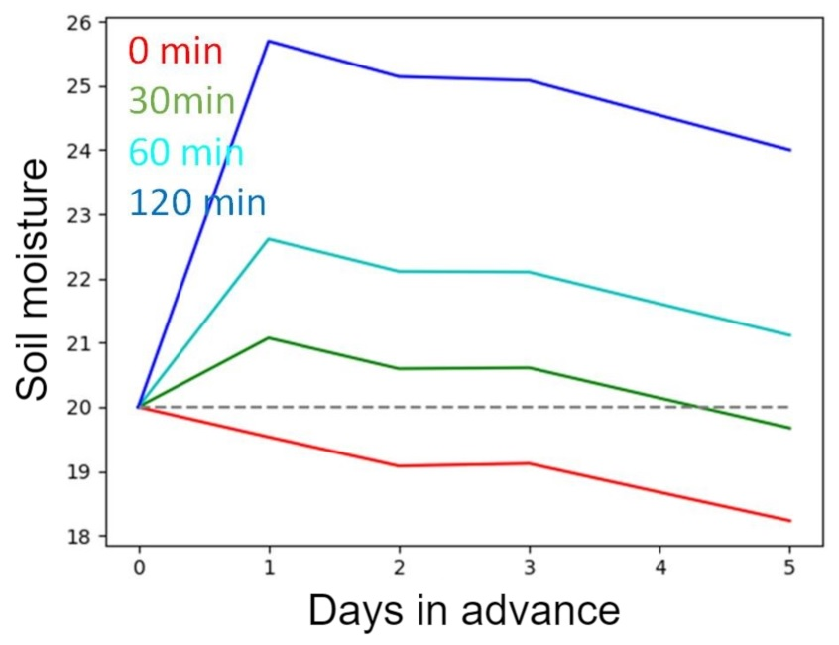
Figure 6. Smart irrigation system based on machine learning predicts the optimal timing and duration of irrigation

7. Digital Field Records

Every proper production should be well-documented. In agriculture, it is a practice to keep field records and, as Serbia is transitioning towards EU legislation, it will soon be obligatory. From the data analytics point of view, paper field records are a huge missed opportunity. Datasets regarding sowing, application of fertilisers and pesticides and harvesting are a “gold mine” for BioSense, but, as a rule, they are written in notebooks and planners and remain on the shelves, hidden from everyone’s eyes. With digital data, through the application of advanced methods of artificial intelligence, machine learning and Big Data analytics, we are able to process huge amounts of data, find hidden dependencies within them, give automatic recommendations to the farmers and make their decisions more efficient. An old Chinese proverb says: “the best time to plant a tree was 20 years ago. The second-best time is now”. Currently we do not have Big Data about agricultural production, but keeping digital field records is an ideal chance to start gathering information, based on which BioSense will develop new modules for the farmers. AgroSense’s Activities module allows users to enter information about the date of the activities conducted on the field and specify details about the type of tillage, applied pesticides, yields and operation costs, while all these activities can be also documented with photographs using AgroSense mobile app. Besides the module with activities, there is a separate module for soil analysis that displays the soil data acquired through the years, and a module that consists of photos that the user has acquired using smartphone and their map based on their GPS locations.

8. Cost Analysis

One of the direct benefits of keeping comprehensive digital field records is that the cost analysis can be conducted with a single click of the mouse. This module uses the information about the activities and their prices and lists the costs according to the crop type or the total costs for the whole farm. The cost analysis is supported by graphs that visually represent the numbers in a clear and understandable way, and which are helping the farmer get a better insight into the financial aspect of the production.

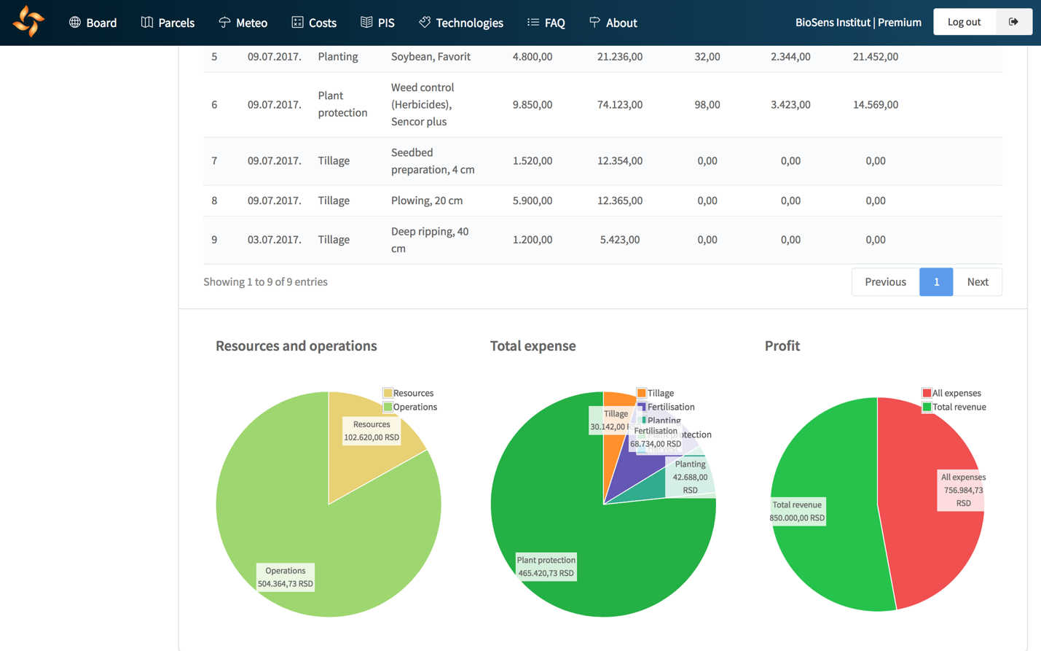
Figure 7. Cost analysis of activities entered through the digital field book

9. Services

Consultancy is one of the fields that will undergo the biggest change due to the digital transformation, as the precise field data will allow advisory services and experts to give more accurate and more efficient advice to the farmer. Based on this module, advisors and farmers will be able to connect more efficiently and, upon the signing of the contract, the advisor will get a full range of information about the crops, from satellite images and parameter maps, over photographs from the field, all the way to the digital field records. Such a detailed dataset leaves a possibility for the expert to perceive the problem from multiple angles and determine the optimal steps in the production, often even without the field visit. Besides the module for advisors, drone pilots will also have their section within the Services module. Conducting business over AgroSense even eliminates the need for any personal contact between the providers and receivers of UAV imaging services. After establishing the contact, the pilot gets GPS coordinates and boundaries of the target parcel, while the images are digitally uploaded to the platform. This makes the business run faster and more efficiently and promotes the use of high-tech in agriculture. Service providers can limit the area of their operation to Serbian counties of interest, so that they could avoid deals from remote locations that are not financially justifiable, due to high travel costs. Another factor in choosing a service provider is the price. Namely, we set up a system for giving ratings to the providers that allow farmers to rate advisors and drone pilots based on the quality of work conducted. This system puts quality service providers on top and allows them to set up their prices according to the quality of their service and the demand. Besides advisors and UAV pilots, we are planning to include sections for laboratories for soil analysis, companies for electrical conductivity scanning of the fields and others. This network will gather different actors in agricultural production and integrate them under one roof – the AgroSense platform.

10. Future Directions

In this text, we presented a few main modules of the platform which rely on IoT and many other sources of data. There are also other ones, for issuing pest alarms, calibration of machinery and education of the users about new IoT devices, new agricultural practices and the government subsidies. All of the listed modules were based on the available data - satellite and drone images, soil moisture sensors and parameters measured by weather stations. However, as farmers are entering new data about their production, new opportunities will arise for the development of additional modules. These modules will serve as decision-support tools and will help farmers increase the yields and decrease the costs, make the production more sustainable and eco-friendly and grow healthier and more quality produce.

11. References

[1] Tzounis, A., Katsoulas, N., Bartzanas, T., & Kittas, C. (2017). Internet of Things in agriculture, recent advances and future challenges. Biosystems Engineering, 164, 31-48.
[2] Kamienski, C., Soininen, J. P., Taumberger, M., Fernandes, S., Toscano, A., Cinotti, T. S., ... & Neto, A. T. (2018, June). SWAMP: an IoT-based Smart Water Management Platform for Precision Irrigation in Agriculture. In 2018 Global Internet of Things Summit (GIoTS) (pp. 1-6). IEEE.
[3] Davcev, D., Mitreski, K., Trajkovic, S., Nikolovski, V., & Koteli, N. (2018, June). IoT agriculture system based on LoRaWAN. In 2018 14th IEEE International Workshop on Factory Communication Systems (WFCS) (pp. 1-4). IEEE.
[4] Patil, K. A., & Kale, N. R. (2016, December). A model for smart agriculture using IoT. In 2016 International Conference on Global Trends in Signal Processing, Information Computing and Communication (ICGTSPICC) (pp. 543-545). IEEE.
[5] Vasisht, D., Kapetanovic, Z., Won, J., Jin, X., Chandra, R., Sinha, S., ... & Stratman, S. (2017). Farmbeats: An iot platform for data-driven agriculture. In 14th {USENIX} Symposium on Networked Systems Design and Implementation ({NSDI} 17) (pp. 515-529).
[6] Popović, T., Latinović, N., Pešić, A., Zečević, Ž., Krstajić, B., & Djukanović, S. (2017). Architecting an IoT-enabled platform for precision agriculture and ecological monitoring: A case study. Computers and Electronics in Agriculture, 140, 255-265.
[7] Capello, F., Toja, M., & Trapani, N. (2016). A real-time monitoring service based on industrial internet of things to manage agrifood logistics. In Proceedings of the 6th International Conference on Information Systems, Logistics and Supply Chain, Bordeaux, France, Available from: http://ils2016conference. com/wpcontent/uploads/2015/03/ILS2016_FB01_1. pdf, Accessed (pp. 10-21).
[8] Brewster, C., Roussaki, I., Kalatzis, N., Doolin, K., & Ellis, K. (2017). IoT in agriculture: Designing a Europe-wide large-scale pilot. IEEE communications magazine, 55(9), 26-33.
[9] “LoRa Alliance”, https://lora-alliance.org/
[10] “Yr.no”, Joint online weather service from the Norwegian Meteorological Institute and the Norwegian Broadcasting Corporation, https://www.yr.no/
[11] Marko, O., Rapid sensors connected in an Internet-of-Things environment: the case of agriculture, Rapid Methods Europe (12; Amsterdam; 2018)

Др, научни сарадник, Институт БиоСенс, др Зорана Ђинђића 1, 21000 Нови Сад, oskar.marko@biosense.rs
Др, научни сарадник, Институт БиоСенс, др Зорана Ђинђића 1, 21000 Нови Сад, sanja.brdar@biosense.rs
Истраживач-сарадник, Институт БиоСенс, др Зорана Ђинђића 1, 21000 Нови Сад, lugonjap@biosense.rs
Др, виши научни сарадник, Институт БиоСенс, др Зорана Ђинђића 1, 21000 Нови Сад, gkitic@biosense.rs
Др, научни сарадник, Институт БиоСенс, др Зорана Ђинђића 1, 21000 Нови Сад, panic@biosense.rs
Др, научни сарадник, Институт БиоСенс, др Зорана Ђинђића 1, 21000 Нови Сад, dkrkljes@biosense.rs
Др, научни саветник, Институт БиоСенс, др Зорана Ђинђића 1, 21000 Нови Сад, crnojevic@biosense.rs

